str = "Python"

for i in str:

print(i)

list = [1,2,3,4,5,6,7,8,9,10]

n = 6

for i in list:

c = n\*i

print(n," \*",i, " =", c)

list = [10,30,20,40,60,12]

sum = 0

for i in list:

sum = sum+i

print("The sum is:",sum)

for i in range(18):

print(i,end=' ')

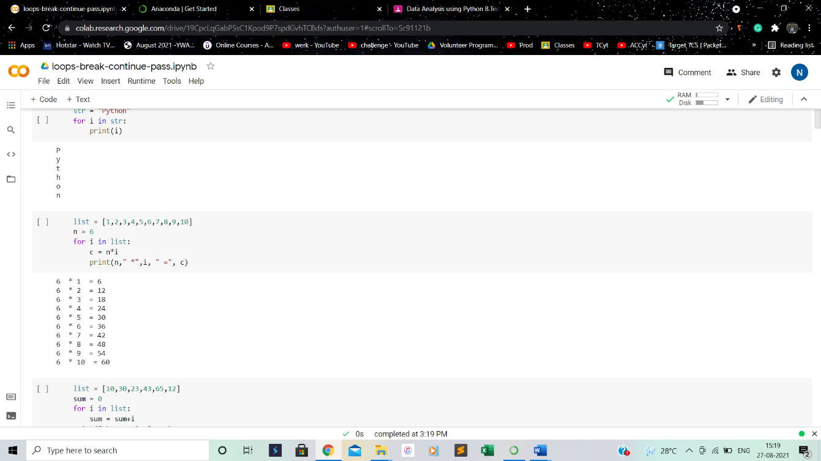

n = int(input("Enter the number "))

for i in range(1,11):

c = n\*i

print(n,"\*",i,"=",c)

n = int(input("Enter the number "))

for i in range(2,n,2):

print(i)

list = ['Rick','Malcom','Dewy','Francis']

   for i in range(len(list)):

       print("Hello",list[i])

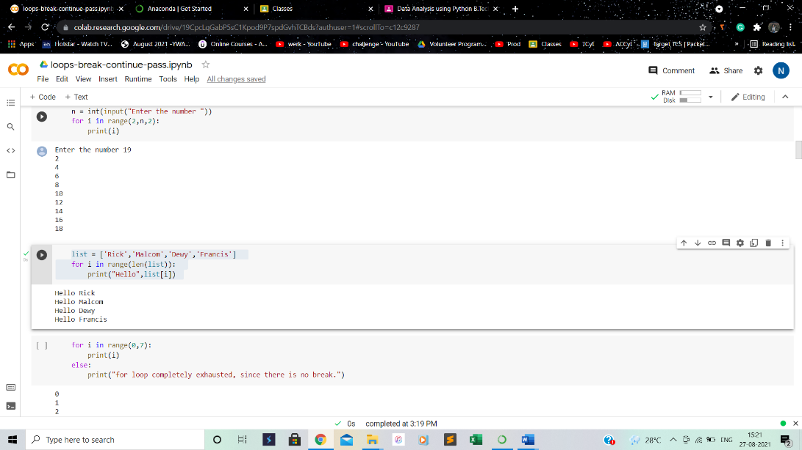

for i in range(0,7):

print(i)

else:

print("for loop completely exhausted, since there is no break.")

for i in range(0,7):

print(i)

print("bye")

continue;

print("hello")

else:print("for loop is exhausted");

print("The loop is broken due to break statement...came out of the loop")

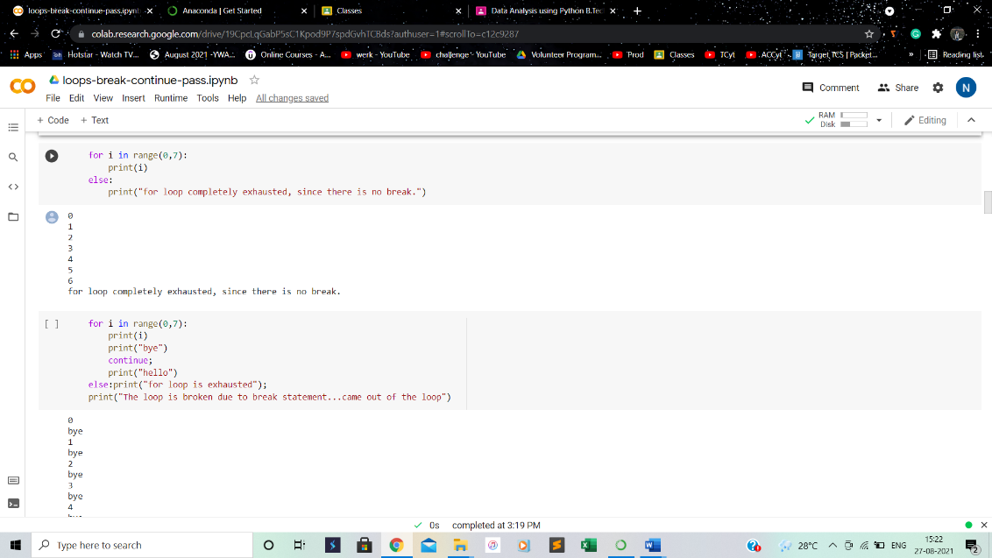

# prints all letters except 'a' and 't'

    i = 0

    str1 = 'neha'

    print(str1)

    while i < len(str1):

        print('entered while loop before if statement')

        if str1[i] == 'a' or str1[i] == 'u':

            print('entered if statement')

            i += 1

            print('i incremented')

            continue

            print('after continue')

        print('Current Letter :', str1[i])

        i += 1

        print('going back to starting of while loop')

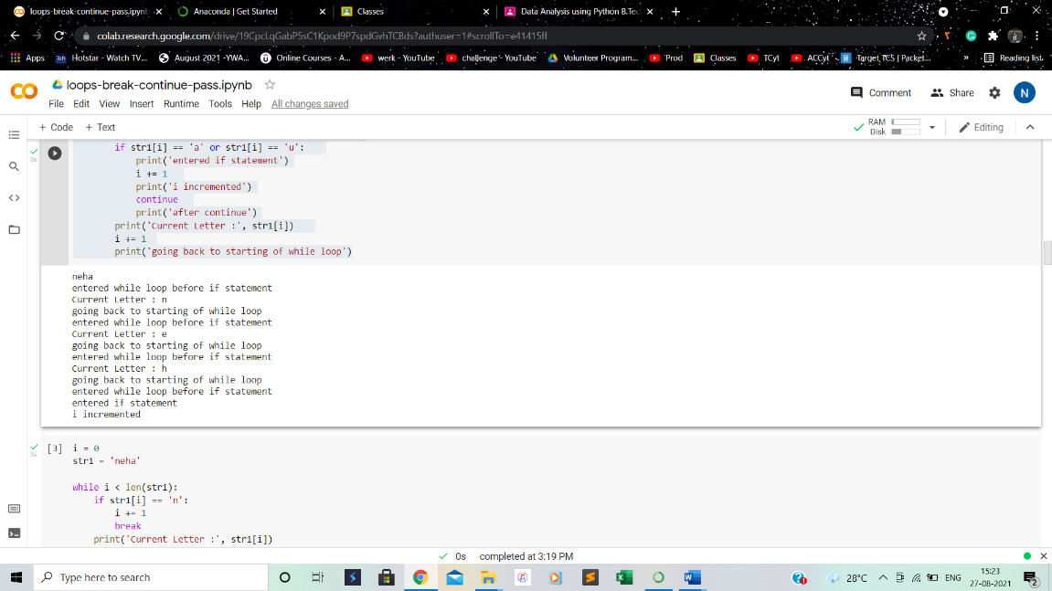

i = 0

str1 = 'neha'

while i < len(str1):

    if str1[i] == 'n':

        i += 1

        break

    print('Current Letter :', str1[i])

    i += 1

#The pass statement is used to declare the empty loop.

#It is also used to define empty class, function, and control statement.

str1 = 'neha'

i = 0

while i < len(str1):

    i += 1

    pass

print('Value of i :', i)

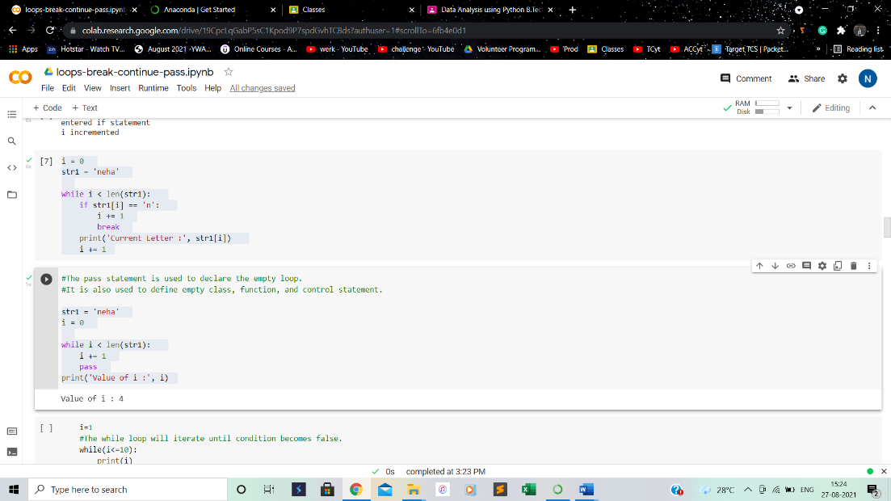

i=1

#The while loop will iterate until condition becomes false.

while(i<=10):

print(i)

i=i+1

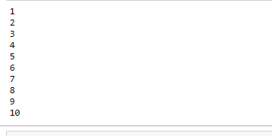

i=1

number = int(input("Enter the number:"))

while i<=10:

print("%d X %d = %d \n"%(number,i,number\*i))

i = i+1

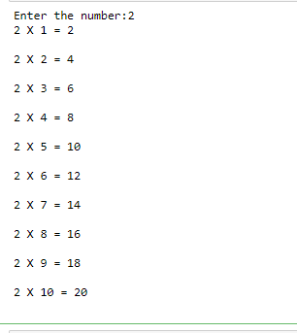

while (1):

print("Hi! we are inside the infinite while loop")

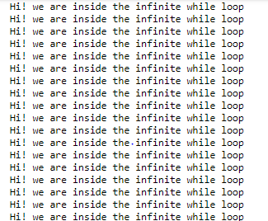

var = 1

while(var != 2):

i = int(input("Enter the number:"))

print("Entered value is %d"%(i))

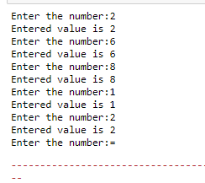

i=1

while(i<=5):

print(i)

i=i+1

else:

print("The while loop exhausted")

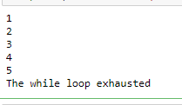

i=1

while(i<=5):

print(i)

i=i+1

if(i==3):

break

else:

print("The while loop exhausted")

print("bye bye")

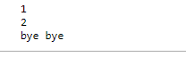

list =[1,2,3,4]

i=1;

count = 2;

for i in list:

if i == 4:

print("item matched")

count = count + 1;

break

print("found at",count,"location");



str = "python"

for i in str:

if i == 'o':

break

print(I);

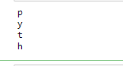

n=2

while 1:

i=1;

while i<=10:

print("%d X %d = %d\n"%(n,i,n\*i));

i = i+1;

choice = int(input("Do you want to continue printing the table, press 0 for no?"))

if choice == 0:

break;

n=n+1

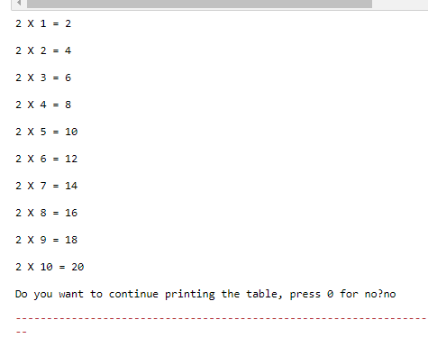

i = 0

while(i < 10):

i = i+1

if(i == 5):

continue

print(i)

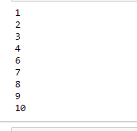

str = "Neha"

    for i in str:

        if(i == 'n'):

            continue

        print(i)

print(i)

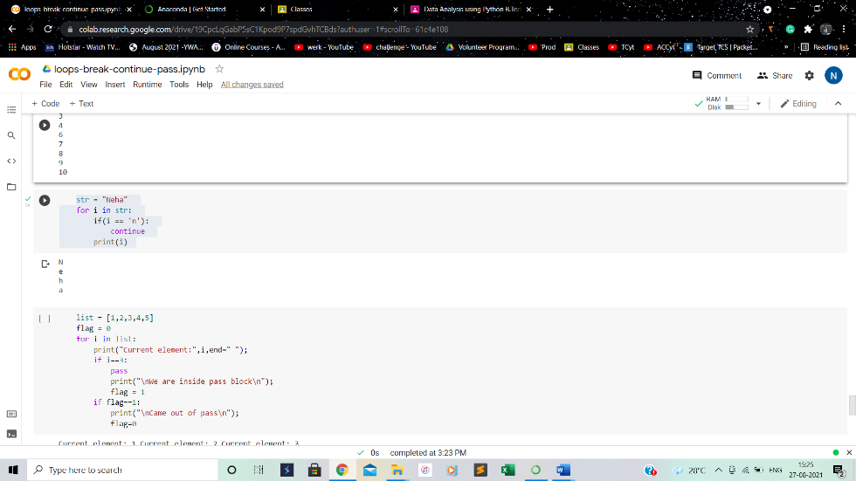

list = [1,2,3,4,5]

flag = 0

for i in list:

print("Current element:",i,end=" ");

if i==3:

pass

print("\nWe are inside pass block\n");

flag = 1

if flag==1:

print("\nCame out of pass\n");

flag=0

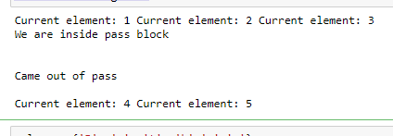

values = {'P', 'y', 't', 'h','o','n'}

for val in values:

pass

for i in [1,2,3,4,5]:

if(i==4):

pass

print("This is pass block",i)

print(i)

